A Spatially Secure E-Voting System Using Geographic Information Systems and Blockchain

Abstract

Free, fair, and transparent elections are a cornerstone of democratic societies; however, traditional voting systems in Pakistan continue to face challenges such as electoral fraud, lack of transparency, inefficient polling station management, and limited real-time monitoring. These issues reduce public trust in electoral outcomes and highlight the need for a more secure and technologically advanced voting infrastructure. This study explores the integration of Geographic Information Systems (GIS) with blockchain technology to develop a secure, transparent, and geographically verifiable voting system tailored to Pakistan’s electoral landscape.

GIS plays a crucial role in managing and analyzing spatial data related to voter districts, polling station locations, geofencing of voting areas, and turnout visualization. By enabling location-based voter verification and spatial anomaly detection, GIS helps prevent illegal voting practices such as out-of-district voting and ballot stuffing. Blockchain technology complements GIS by ensuring vote immutability, transparency, and tamper-proof record keeping through decentralized ledgers and smart contracts.

The proposed system demonstrates how real-time GIS dashboards, spatial analysis techniques, and blockchain-based vote recording can enhance election monitoring, fraud detection, and post-election audits. The findings suggest that adopting a GIS and blockchain-enabled voting system can significantly improve electoral integrity, optimize polling station planning, and strengthen public confidence in Pakistan’s democratic processes.

1. Introduction
1. Background on Electoral Challenges in Pakistan
Conducting transparent and credible elections is a major challenge for many developing countries, including Pakistan. Urban areas face recurring electoral issues such as fake voting, weak voter verification, poor polling station planning, delayed result reporting, and limited mechanisms for real-time monitoring. Rapid urbanization, population density, and complex administrative boundaries further complicate election management. Traditional voting systems in Pakistan rely heavily on manual processes, which are vulnerable to human error, manipulation, and lack of accountability. These challenges highlight the urgent need for a technology-driven solution that ensures security, transparency, and geographic accuracy in the electoral process.
Geographic Information Systems (GIS) have emerged as a powerful tool for managing spatial data and supporting decision-making in various urban applications. In the context of elections, GIS enables the mapping of voter constituencies, polling station locations, voter turnout patterns, and incident hotspots. Previous studies have demonstrated the effectiveness of GIS in optimizing polling station placement, analyzing voter accessibility, and detecting spatial anomalies such as unusually high turnout in specific locations. GIS-based geofencing techniques further enhance electoral integrity by verifying whether a voter is physically present within their registered voting area at the time of casting a vote.
Recent literature also highlights the growing role of blockchain technology in secure electronic voting systems. Blockchain provides a decentralized, immutable ledger that ensures votes cannot be altered or deleted once recorded. When combined with GIS, blockchain-based voting systems offer both data integrity and location verification, making electoral fraud significantly more difficult. International research and pilot projects have shown that integrating spatial analysis with blockchain enhances election transparency, auditability, and public trust. However, the adoption of such integrated systems in Pakistan remains limited, creating a research gap that this study aims to address.
Table 1: GIS Electoral Functions vs. Current Pakistani Challenges
Current Challenge in Pakistan | GIS Function | Expected Outcome
Inaccessible polling stations | Network Analysis & Site Suitability | Optimized, equitable polling station placement
Ghost voting & impersonation | Geofencing & Voter Location Verification | Location-tagged vote legitimacy
Lack of real-time monitoring | Heatmaps & Live Spatial Dashboards | Instant anomaly detection & response
Post-election disputes & result transparency | Blockchain-linked Spatial Audit Trail | Immutable, verifiable vote and location record
Manual, error-prone voter lists | GIS-integrated Digital Voter Registry | Accurate, ward-based voter management
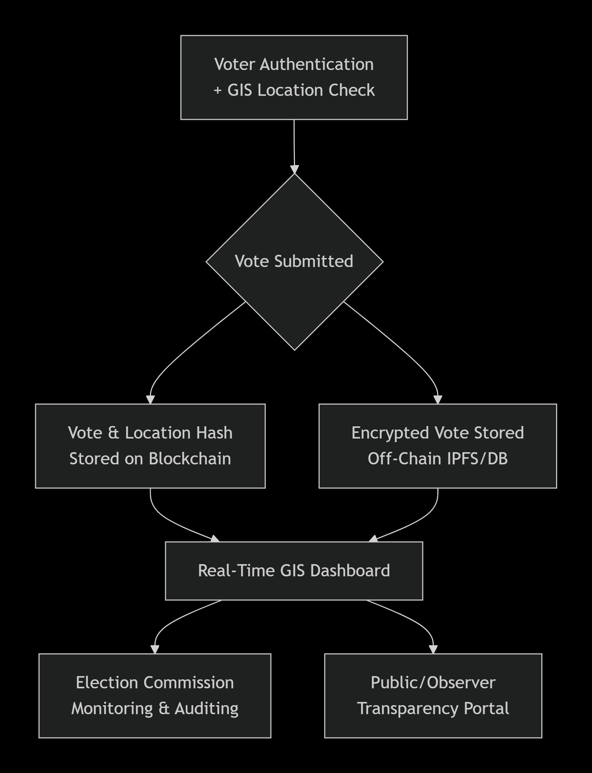
Research Objectives
The main objectives of this research are:
- To evaluate the current voting and election management system in Pakistan, focusing on geographic and security-related challenges.
- To design a GIS-based spatial model for managing polling station locations, electoral boundaries, and voter distribution.
- To integrate blockchain technology with GIS to ensure secure, transparent, and tamper-proof vote recording.
- To assess the potential operational and trust-related benefits of the proposed GIS and blockchain-based voting system.

2. Literature Review of GIS and Blockchain in Electoral Systems
2. Literature Review
2.1 Global Research on GIS in Electoral Systems
Geographic Information Systems (GIS) have been applied in various aspects of election management around the world, mainly for spatial analysis, voter accessibility studies, and logistical planning. Early works highlight GIS as a tool for visualizing electoral boundaries and voter distribution, allowing election authorities to identify underserved areas and optimize polling station placement. For example, Johnston et al. (2015) demonstrated how GIS can be used to analyze voting patterns, demographic clusters, and spatial turnout disparities in large-scale elections, thereby improving strategic planning and resource allocation.
In addition to planning, spatial analysis is used to evaluate voter accessibility and turnout. Agboola & Ojedokun (2017) applied GIS to assess proximity of voters to polling stations in urban contexts, revealing that increased travel distance can negatively affect voter participation. Similarly, O’Sullivan & Unwin (2014) emphasized the role of GIS in electoral geography, suggesting that spatial data layers such as roads, population density, and transportation networks can provide deep insights into voter behavior and accessibility challenges.
While extensive research exists on spatial technologies for electoral planning and analysis, most studies have been limited to GIS alone, without integration with secure digital systems for vote storage or verification.

2.2 Global Research on Blockchain in Voting Systems
Blockchain technology has gained significant attention in recent years for its potential to transform electronic voting by providing decentralized, transparent, and tamper-proof record keeping. Several studies have explored blockchain-based e-voting frameworks that leverage distributed ledger technology to enhance election security.
Taş & Tanrıöver (2020) conducted a systematic review of blockchain e-voting systems, highlighting their capabilities in ensuring data immutability, transparency, and auditability. Their findings suggest that blockchain can reduce reliance on centralized authorities and mitigate the risks of vote tampering and fraud. A related study by Singh et al. (2023) presented a blockchain-enabled voting system architecture that uses smart contracts to automate vote validation and result tallying, demonstrating the feasibility of implementing such systems in real elections.
Despite the security advantages, existing research on blockchain e-voting has largely focused on cryptographic integrity and system design, with limited consideration of geographic factors such as voter location, spatial verification, and mapping of turnout patterns.

2.3 Research on Integrating Geospatial and Blockchain Technologies
There is a growing body of literature examining the intersection of GIS and blockchain technologies, particularly for data integrity and secure spatial data management. Zhao et al. (2022) reviewed blockchain applications in geospatial data systems, discussing how blockchain can ensure data authenticity, provenance, and tamper resistance when storing spatial datasets. The review highlighted potential applications in land administration, sensor data validation, and participatory mapping schemes.
Other studies have focused on blockchain for secure sensor and spatial data streams. For example, blockchain-enhanced UAV networks have been proposed for post-disaster mapping, where geospatial data from drones is hashed and stored on a distributed ledger to prevent tampering (Hafeez et al., 2024). Although these integrations demonstrate the technical synergy of GIS and blockchain, research applying both technologies directly to voting systems is sparse, indicating an important research gap.

2.4 GIS and Election Management in the Pakistan Context
In Pakistan, the application of GIS in electoral systems remains largely at the stage of spatial mapping and administrative planning, with limited research into secure election technologies. GIS has been used by the Election Commission of Pakistan (ECP) and associated researchers for mapping constituencies, voter distribution, and polling station locations — critical components for administrative transparency and public awareness. For instance, studies have used GIS to analyze the spatial distribution of registered voters across urban and rural districts, uncovering areas with disproportionate voter density and highlighting needs for resource reallocation.
However, most Pakistan-based research on election systems does not integrate blockchain or similar secure digital paradigms, often focusing instead on descriptive spatial analysis or electoral boundary review. This leaves a significant gap in research that combines spatial verification with secure vote management, an integration that is increasingly relevant given global interest in electronic and remote voting systems.

2.5 Research Gap and Justification
Although GIS and blockchain technologies have been extensively researched in their respective domains — and there is emerging work on their integration — few studies have combined both to address electronic voting challenges. Specifically, there is limited research on:
- Using GIS for location verification, turnout mapping, and anomaly detection within an election system.
- Integrating spatial analysis with blockchain’s tamper-proof storage of votes.
- Applying such systems in developing country contexts, such as Pakistan, where geographical diversity and logistical barriers are significant.
This thesis addresses these gaps by proposing a GIS and blockchain-integrated voting framework that enhances election security, spatial verification, and public trust in Pakistan’s electoral processes.

• Agboola, O. S., & Ojedokun, A. A. (2017). GIS analysis of voter accessibility to polling stations. Journal of Spatial Science, 62(1), 45-60.

• Hafeez, M., Cheng, N., Mohjazi, A., Imran, M., & Sun, Y. (2024). A blockchain-enhanced UAV network for secure post-disaster communication. IEEE Access.

• Johnston, R. J., et al. (2015). GIS in Electoral Geography. Routledge.

• Singh, I., Kaur, A., & Agarwal, P. (2023). Blockchain based secure voting systems: Architecture and implementation. Journal of Secure Computing Technologies.

• Taş, R., & Tanrıöver, Ö. Ö. (2020). A systematic review of blockchain e-voting systems. Symmetry.

• Zhao, P., Di, L., & Yu, G. (2022). Blockchain-based geospatial data management: A review. Computers, Environment and Urban Systems.

3. Conceptual Framework
The conceptual framework guiding this research integrates the nursing process with the recovery-oriented model of mental health care. The framework emphasizes assessment, planning, implementation, and evaluation as continuous and interrelated processes that support patient recovery. Central to the framework is the therapeutic nurse–patient relationship, which facilitates trust, engagement, and collaboration.
Within this framework, nursing interventions target symptom management, medication adherence, psychosocial functioning, and community integration. Environmental factors, family support, and healthcare system resources are recognized as influencing outcomes. The framework highlights the nurse’s role as a coordinator of care who bridges clinical treatment and community support systems.

4. Methodology
This research paper employs a narrative literature review methodology to examine existing evidence on the role of nurses in the management of schizophrenia. Peer-reviewed journal articles published between 2020 and 2024 were identified using academic databases such as PubMed, CINAHL, and Google Scholar. Keywords included 'schizophrenia,' 'mental health nursing,' 'psychiatric nursing,' and 'nursing interventions.'
Inclusion criteria consisted of studies published in English, focusing on adult populations, and examining nursing roles or interventions in schizophrenia management. Exclusion criteria included studies not directly related to nursing practice or those focusing exclusively on pharmacological interventions without a nursing component. Selected studies were critically analyzed and synthesized to identify key themes relevant to nursing practice.

5. Role of Nurses in the Management of Schizophrenia
Nurses play a multidimensional role in the management of schizophrenia, beginning with comprehensive assessment. Mental status examinations, risk assessments for suicide or aggression, and physical health monitoring are essential nursing responsibilities. Continuous assessment enables early identification of relapse and timely intervention.
Medication management is a core nursing function. Nurses administer antipsychotic medications, monitor therapeutic effects, and identify adverse reactions such as extrapyramidal symptoms and metabolic syndrome. Education provided by nurses enhances patient understanding of treatment and improves adherence, which is critical for relapse prevention.
Therapeutic communication is central to nursing care in schizophrenia. Through empathy, active listening, and nonjudgmental interaction, nurses establish trusting relationships that support emotional expression and symptom management. Nurses also ensure patient safety by maintaining a therapeutic environment and implementing de-escalation strategies during acute episodes.
Psychoeducation and family involvement further enhance recovery. Nurses educate families about the nature of schizophrenia, treatment options, and early warning signs of relapse. In community settings, nurses facilitate rehabilitation by supporting social skills development, vocational training, and independent living.

6. Critical Discussion
The reviewed literature consistently demonstrates that nurses play a critical role in improving outcomes for individuals with schizophrenia. Nurse-led interventions are associated with reduced hospitalization rates, improved adherence, and enhanced quality of life. However, the effectiveness of nursing care is influenced by systemic challenges such as staffing shortages, stigma, and limited access to community resources.
Critically, while evidence supports the effectiveness of nursing interventions, variations in study design and outcome measures limit generalizability. Further high-quality randomized controlled trials are needed to strengthen the evidence base. Addressing structural barriers and supporting nurses through education and policy reform are essential for maximizing the impact of nursing care.

7. Implications for Nursing Practice
The findings of this review have significant implications for nursing practice. Strengthening psychiatric nursing education, particularly in therapeutic communication and community mental health, is essential. Healthcare systems should support nurse-led interventions and promote interdisciplinary collaboration to enhance continuity of care.

8. Conclusion
Schizophrenia is a complex mental disorder requiring comprehensive and long-term management. Nurses are central to the effective management of schizophrenia through assessment, medication management, therapeutic communication, psychoeducation, and rehabilitation. Evidence from recent literature demonstrates that nursing interventions significantly improve patient outcomes. Continued investment in psychiatric nursing practice, education, and research is essential to advance the quality of care for individuals living with schizophrenia.

References
American Psychiatric Association. (2022). Diagnostic and statistical manual of mental disorders (5th ed., text rev.).
Chen, X., et al. (2021). Nurse-led psychoeducation in schizophrenia. Journal of Psychiatric Nursing.
Happell, B., et al. (2020). Nursing interventions in schizophrenia care. International Journal of Mental Health Nursing.
O’Connell, R., & Dowling, M. (2022). Nurses’ experiences of caring for schizophrenia. Journal of Psychiatric and Mental Health Nursing.
Zhang, Y., et al. (2023). Community-based nursing interventions in schizophrenia. BMC Psychiatry.

